Assimp_qt_viewer

1. Purpose and interface of the program.

1.1. Program purpose is fast evaluation of the work of Assimp library.
1.2. The program interface after launch is shown on the image 1.

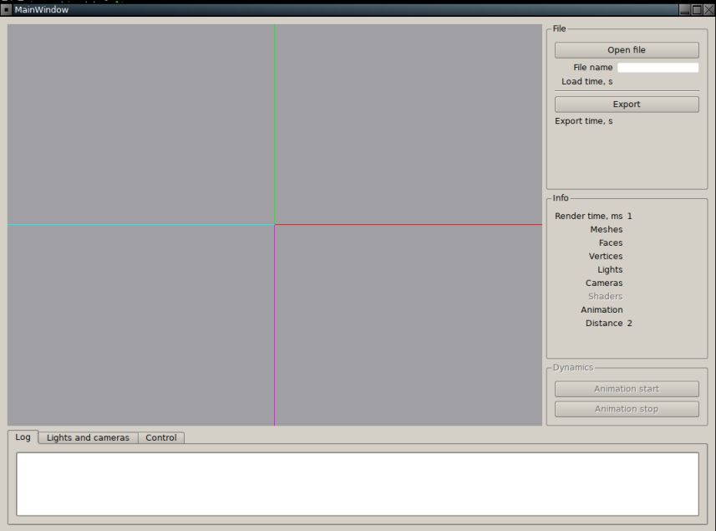
Image 1. The program interface.

1.3. Coordinate axes.

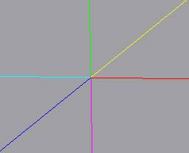
Image 2. Coordinate axes.

Axes of coordinate system of a scene are shown by color lines:
а) +oX — red;
б) -oX — cyan;
в) +oY — green;
г) -oY — magenta;
д) +oZ — blue;
е) -oZ — yellow.

2. Importing of the scene.

2.1. For importing the scene: press button «Open file» and choose file of the scene.

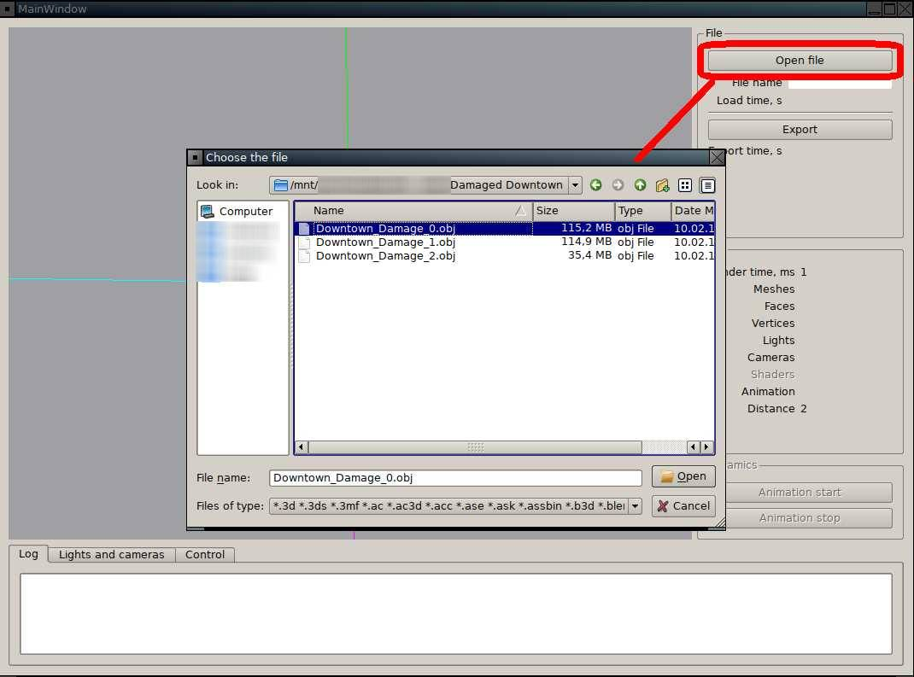

Image 3. Importing of the scene.

2.2. After the scene is imported

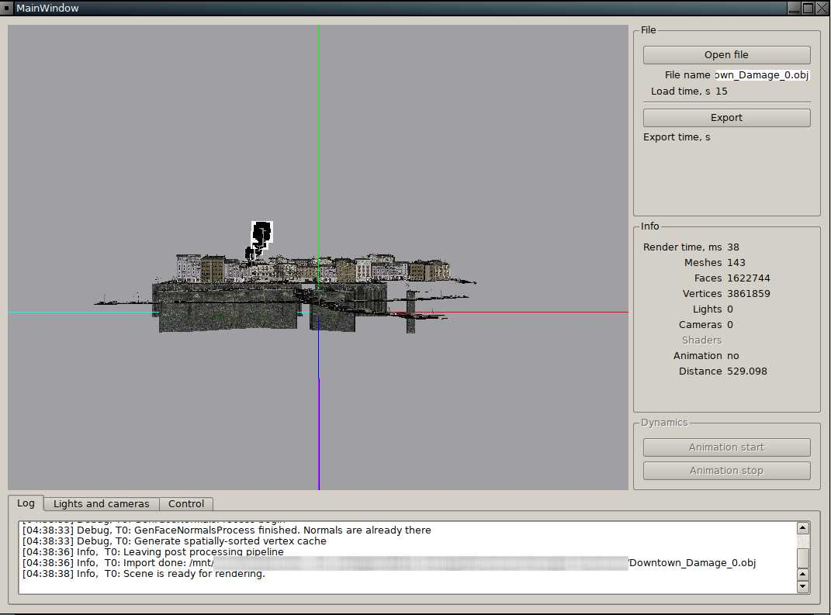
Image 4. Scene visualisation.

can be viewed:
а) Information about the file: file name of the scene and time spent for import of the file (in seconds, without takin into account time of loading of additional files with resources). File name accessible for selecting by mouse and copying.

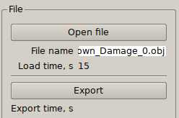
Image 5. Information about the file.

б) Log.

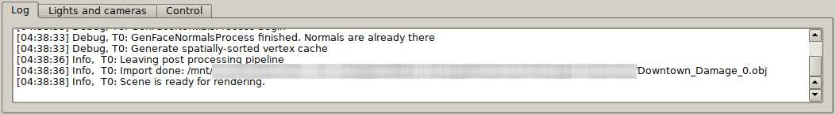
Image 6. Program log.

в) Information about the scene:
ва) Rendering time, in milliseconds. Updated after every rendering of the scene.
вб) Quantity of the loaded objects — meshes, faces, vertices, light sources, cameras.
вв) There is an animation or not.
вг) Distance between the center of a scene and position of the current camera. Updated after every change of position a camera or a scene/

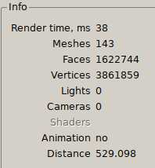
Image 7. Information about the scene.

г) Management of light sources and cameras.

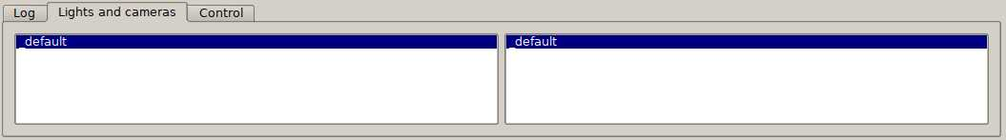
Image 8. Management of light sources and cameras.

д) Management of other parameters of a scene.

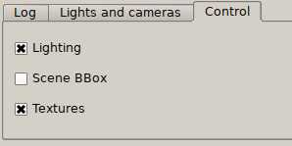
Image 9. Management of other parameters of a scene.

3. Exporting of the scene.

3.1. For exporting of the scene: press button «Export», choose the catalog and enter name of the file.

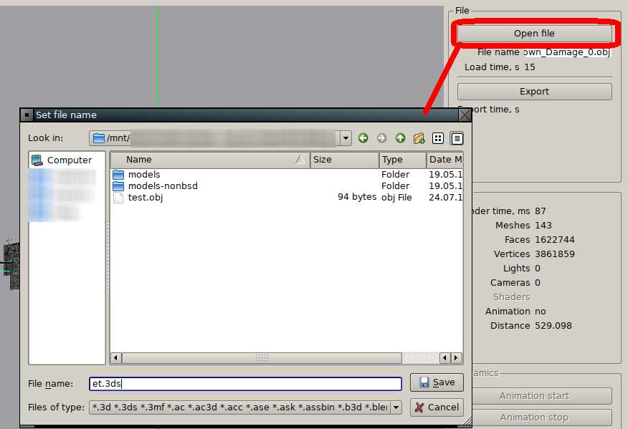
Image 10. Exporting of the scene.

3.2. According to Assimp, export format is set by extension of the file.
3.3. Information about export is showing in log. Also, time that was spent for export is shown, in seconds.

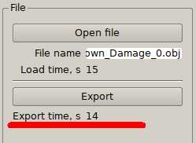
Image 11. Time that was spent for export.

4. Light sources and cameras.

4.1. All light sources of the scene is placed in list (Image 8).
4.2. If in a scene light sources are not set then the default light source is added. The default light source has type «point», the name «_default» and placed under a scene.
4.3. Each of light sources can be turned on or of. Change of a state happens pressing by the left button of a mouse on a light source name in the list.
4.4. Also, lighting calculation can be turned on or off.
4.5. Looking of part of a scene at various values of parameters of visualisation:

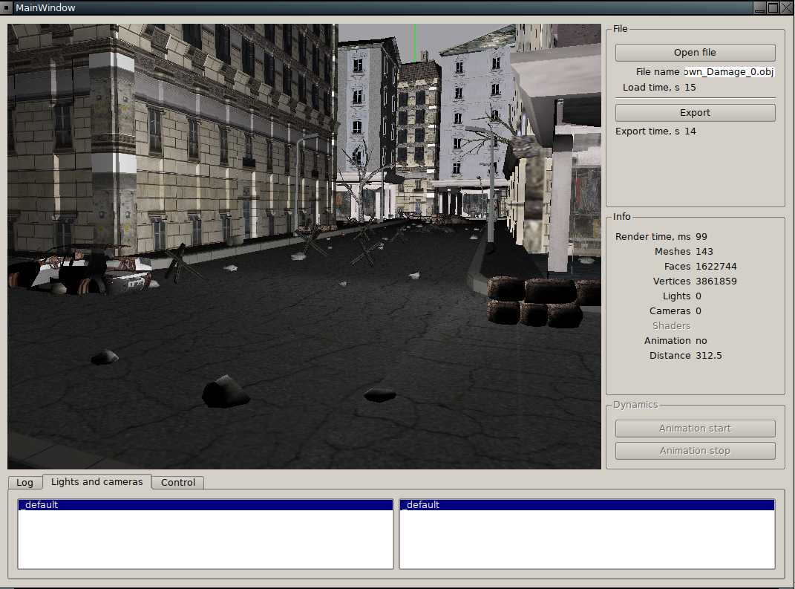
Image 12. Lighting — turned on, light source «_default» — turned on, texturing — turned on.

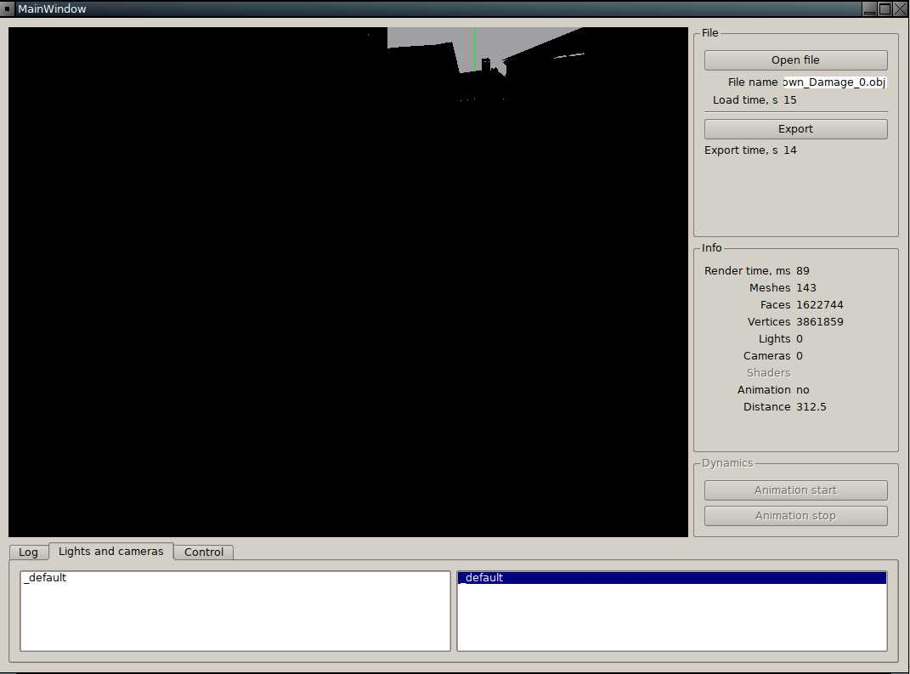
Image 13. Lighting — turned on, light source «_default» — turned off, texturing — does not matter.

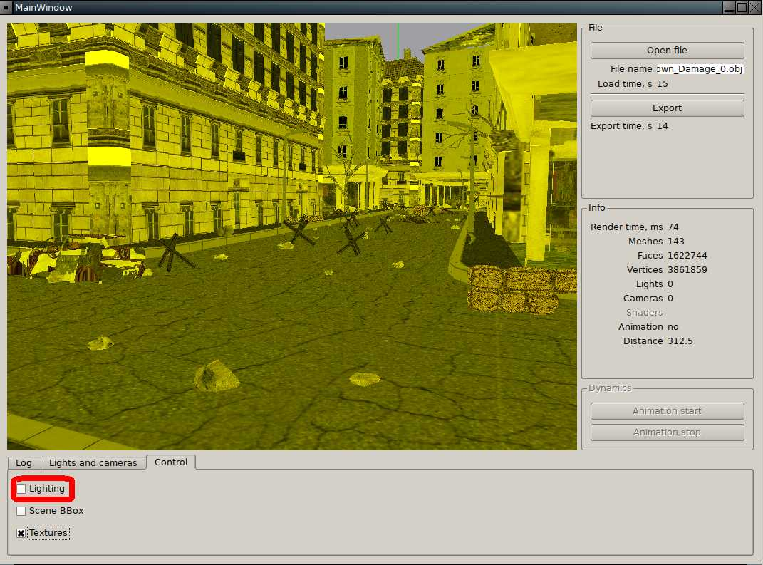
Image 14. Lighting — turned off, light source «_default» — does not matter, texturing — turned on.
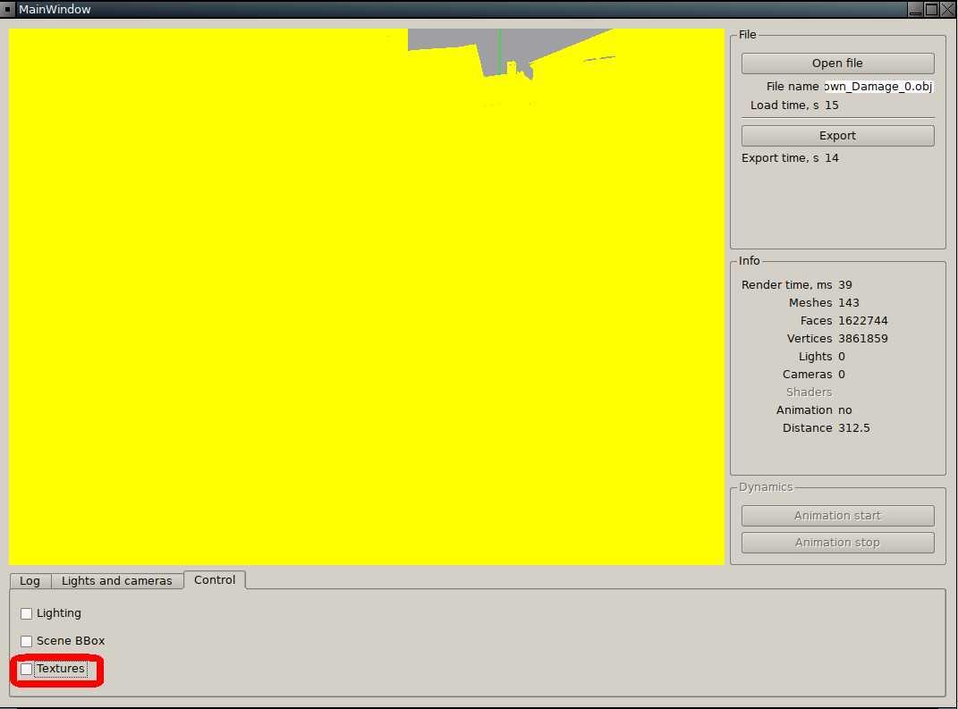
Image 15. Lighting — turned off, light source «_default» — does not matter, texturing — turned off.

4.6. All cameras of the scene is placed in a list (Image 8).
4.7. If in a scene cameras are not set then the default camera is added. The default camera has name «_default». Initial position of such camera such is that all scene was visible on the screen.
4.8. To set an initial look of current or other camera, it is needed to press in the list of cameras it name by the left button of a mouse.

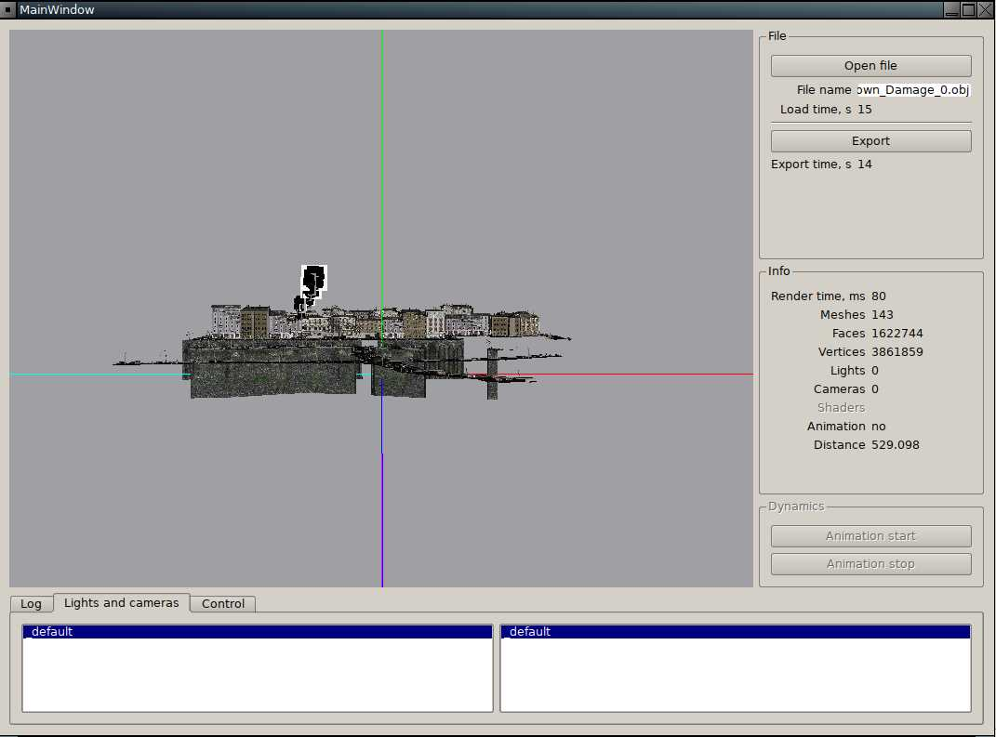
Image 16. Return to an initial position of the «_default» camera after viewing of part of a scene (Image 8).

5. Management of other parameters of scene visualisation.

а) Lighting management: images 12, 14, 15.
б) Management of showing bounding box of the scene.

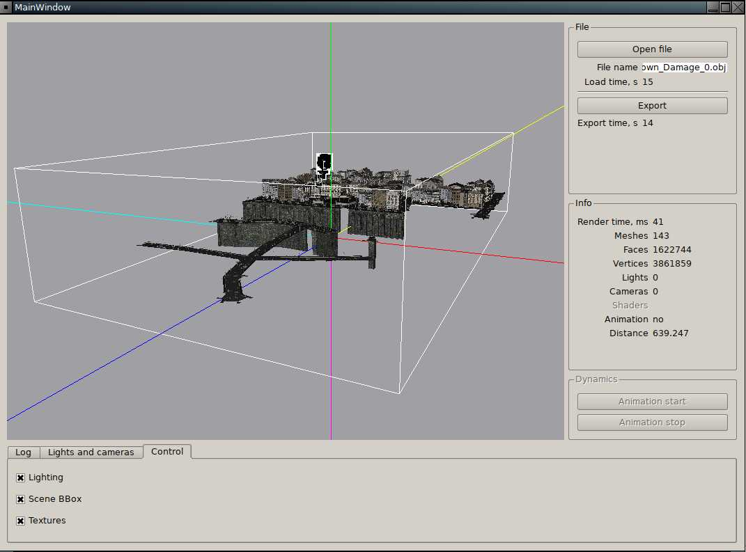
Image 17. Showing bounding box of the scene.

в) Management of texture visualisation. Images 12, 18.

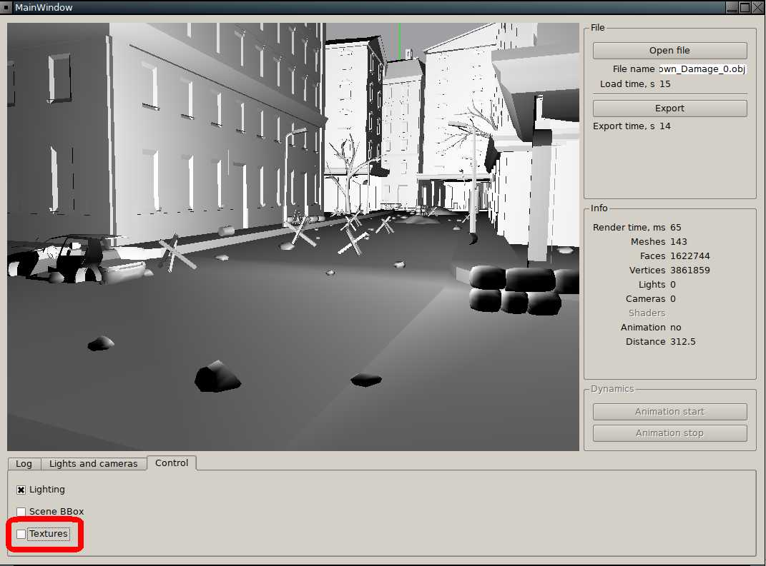
Image 18. Lighting — turned on, light source «_default» — turned on, texturing — turned off.

6. Management of position of a camera and scene.

6.1. Management of position of camera using keyboard. For moving of a camera along coordinate axes (world coorinate system) the following keys and their combinations are used:
а) «D» - axis oX, increase value of coorinate on 1;
б) «A» - axis oX, decrease value of coorinate on 1;
в) «W» - axis oY, increase value of coorinate on 1;
г) «S» - axis oY, decrease value of coorinate on 1;
д) «Down» - axis oZ, increase value of coorinate on 1;
е) «Up» - axis oZ, decrease value of coorinate on 1;
ё) while using keys (а)-(е) with key «Ctrl», value of coordinate is increased on 10;
ж) while using keys (а)-(е) with key «Alt», value of coordinate is increased on 100;
6.2. For rotating of a camera is needed to press the right button of a mouse on a viewport and move the mouse coursor. Movement of the mouse cursor in the two-dimensional plane of viewport is translating in turn around coordinate axes (world coordinate system) as follows:
а) mouse coursor along oX — camera around oY;
б) mouse coursor along oY — camera around oX;

If at the same time to hold pressed the «Shift» on the keyboard:
а) mouse coursor along oX — camera around oZ;
б) mouse coursor along oY — camera around oX;
6.2. For rotating of a scene is needed to press the left button of a mouse on a viewport and move the mouse coursor. Movement of the mouse cursor in the two-dimensional plane of viewport is translating in turn around coordinate axes (coorinate system of the scene) as follows:
а) mouse coursor along oX — scene around oY;
б) mouse coursor along oY — scene around oX;

If at the same time to hold pressed the «Shift» on the keyboard:
а) mouse coursor along oX — scene around oZ;
б) mouse coursor along oY — scene around oX;

7. Limitation of the developed version.

7.1. The program is in development and not all features are realized.
7.2. Spuported only basic abilities for displaying geometry and materials. Not supported:
а) multitexturing — only one texture and only for channel «Diffuse»;
б) embedded textures;
в) transparent materials;
б) animation;
в) shaders;
г) import and export parameters;
д) checking of the OpenGL version and available features of the video card.
7.3. Minimal needed optimisation level — for visualisation vertex buffers are used.
7.4. Clip planes of the perpspective matrix are set by constants.
7.5. After change of the scene position, the new position of light sources is not calculating.

